Angus Health and Social Care Partnership
Annual Workforce Plan Update
2023
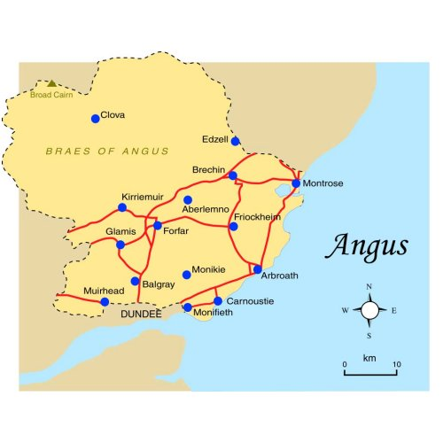
CONTENTS
Section | Page Number (s)
Overview
Introduction | 3
Engagement | 3
Equalities | 3
Section 1- Defining the Plan
Purpose | 3-4
Workforce | 4-5
Financial Implications | 5-6
Section 2 – Mapping Service Change
Overview of Progress in the last 12 Months | 6-11
Impact on the Workforce | 11-13
Workforce Challenges | 13-14
Strategic Workforce Risk | 14-15
Managing the Service Change | 15
Section 3 – Defining the Required Workforce
Workforce Activity Analysis | 15
Skills Development | 16
Workforce Growth | 16-18
Culture and Leadership | 18-20
Section 4 – Understanding Workforce Availability
Staff Numbers | 20-21
Contract Status | 21-22
Vacancy Information | 22-23
Staff Absence | 23-27
Age | 27-32
Gender | 32-33
Workforce Forecasting | 33-34
Section 5 – The Action Plan
Priority Planning | 34
Action Planning | 34-35
Section 6 – Implementing, Monitoring and Reviewing
Implementation | 35
Measuring Progress | 35
Reviewing the Plan | 35
Glossary of Terms and Abbreviations | 36

Overview

Introduction
Scottish Government requires the Angus Health and Social Care Partnership (AHSCP) to have a three year workforce plan commencing July 2022. The three year plan and accompanying action plan can be viewed here https://www.angushscp.scot/workforce/.
The plan requires updating on an annual basis to reflect on progress and illustrate if our workforce priorities and challenges remain the same as the previous year, or if these have changed, why, and what they currently are. This is the first annual update.
This annual update follows the six steps to workforce planning approach and cognisance has also been given to a variety of national and local plans as referenced in our three year plan.
Engagement
In May 2023, a questionnaire was sent to all services across the AHSCP. A positive response was received across services, and this provided information to inform the annual workforce plan update.
Equalities

An Equalities Impact Assessment (EQIA) has been developed alongside this annual workforce plan update. The EQIA process commenced at the earliest stage of the plan development to ensure that equality implications were considered throughout the development of the plan. As part of the EQIA process, the impact of this plan will be monitored throughout its implementation to ensure that mitigating actions continue to be identified and appropriate action taken to minimise any negative impact this plan may have on people who have protected characteristics as specified in the Equality Act 2010 (discrimination against someone due to age, disability, gender reassignment, marriage and civil partnership, pregnancy and maternity, race, religion or belief, sex and sexual orientation).

SECTION 1: DEFINING THE PLAN

Purpose
The purpose of this annual workforce plan update is to support the AHSCP to have the right people, with the right skills, in the right places, at the right time, to fulfil its mandate and its strategic objectives, and to continue to provide high-quality, person-centred care now, and in the future.
The plan provides data comparison and analysis from last year to the present and uses this information to reflect on whether our workforce priorities and challenges remain the same. It highlights any changes and reflects on progress made with workforce priority actions over the last 12 months and what impact, if any, these have had.
It is accompanied by an update on the three year workforce action plan. The action plan contains specific actions relating to how we will attract, retain and develop our workforce in order to meet current and future workforce requirements and contribute to the national long term aim for health and social care in Scotland for people to live longer, healthier lives at home or in a homely setting.
Workforce
This plan adopts a whole system approach in which the statutory services, third and independent sectors (including unpaid carers) operate in partnership; this means that references to the workforce should be taken to include all sectors, unless otherwise stated.
Table 1 provides a comparison snapshot of the total number of staff employed across a range of services in the AHSCP in July 2022 and July 2023. This illustrates a significant increase in Angus Council staff in the last 12 months. This could be attributed to a range of factors such as more vacant posts being filled, additional posts being created either in response to growing demand, staff health and wellbeing issues and service redesign or existing resources being utilised more efficiently. It may also be attributed to services being creative around ‘hard to fill’ posts by identifying alternative posts to meet specific gaps in the workforce.
NHS Tayside total numbers of staff have remained mainly static, with a slight increase of 3 whole time equivalent posts since last year.
Difficulties remain in obtaining workforce data from the Third Sector although the Scottish Social Services Council release an annual data return, which has informed the figures in Table 1.
Table 1

 | WTE July 2022 | WTE July 2023 | Head Count July 2022 | Head Count July 2023
Angus Council | 564 | 590 | 737 | 778
Third Sector | xxx | xxx | 820 | xxx
NHS Tayside | 741 | 744 | xxx | 979
Care Homes | xxx | xxx | 1,478 | xxx
Care at Home | xxx | xxx | 1,860 | xxx
Total Head Count |  |  | 4,895
WTE - Whole Time Equivalent
Head Count- Actual number of employees
*Figures are an approximation based on 2022/23 internally held data
xxx – data not available/not collected in this format

** Detailed data from SSSC in relation to Care Homes and Care at Home figures are still to be published. However, the SSSC report on 2022 workforce data has just been published and illustrates the headcount by local authority area and employer type for 2022 for workers registered with the SSSC. The breakdown for Angus can be viewed below. It should be noted that these figures include childcare workers.

Public | Private | Voluntary | Total
1,540 | 1,900 | 730 | 4,170

Financial Implications
The Angus IJB published its updated Strategic Financial Plan for the period 2023/24 to 2025/26 in April 2023. The plan has been developed in an uncertain and challenging environment and acknowledges that a number of financial risks remain.
It has remained a general assumption that most of the IJB’s demographic pressure will be in services responding to increases in older age group populations and long term conditions (e.g. home care, care management, community nursing and prescribing) and that, for example, the inpatient and residential care home components of care within the Angus IJB will not be expected to see capacity growth, albeit may see changes in acuity. There will also be changes in pressure on Disability Services and the likes of Mental Health and Urgent Care services.
While this principle may still be valid, the capacity of the IJB to continue to support further increases in demographic pressures is now extremely limited. On that basis, and for this iteration of the financial plan, it is now assumed that only a nominal allowance is made for further demographic pressures. This nominal allowance would have to cover any required increases in budgets across all services and in all settings (i.e., community services, residential services and hospital settings). This is a significant change to the IJB’s overall planning and puts a much-increased focus on services either containing the impact of demographic and service pressures through local re-prioritisation or mitigation of the pressures.
It should be noted that all services in the Partnership have benefitted from the 2021/22 to 2022/23 Scottish Government funding for Expanding Care at Home, Multi-Disciplinary Teams, Health and Social Care staffing and Chief Social care Officer Funding. That investment totalled over £4.5m on a recurring basis.
The strategic financial plan notes the following risks in relation to workforce:
- Reviews of Safe Staffing issues re Health and Care (Staffing) (Scotland) Act and review of healthcare tasks in community setting.
- Community Nursing – Job re-evaluations may require reworking of workforce models.
- Workforce and recruitment issues may have a knock on effect on IJB costs beyond service delivery issues.
- Demographic Pressures – e.g., in Older People Services reflecting population changes.
- National Care Service – there may be implications for funding arrangements or managing issues such as changed to “Charging arrangements.”

The Strategic Financial plan demonstrates the IJB’s overall position is one that shows increasing underlying overspends as the IJB struggles to contain forecast increases in costs (without factoring the impact of all likely risks or demographics) within the available funding.
The short-term reliance on non-recurring under spends and contingency funds is not a strategic solution to the underlying shortfall. It is therefore the case that the IJB’s current Strategic Commissioning Plan (2023/24 to 2025/26) cannot be confirmed as being deliverable within the forecast available resources. Therefore, it will be necessary for the IJB to revisit the content of the Delivery Plan and this Strategic Financial Plan. This will be to ensure that further iterations of these documents can align such that the IJB can be assured that the Strategic Commissioning Plan can be delivered within the available resources over the period 2023/24 to 2025/26. It is further possible, that the IJB may have to revisit the content of the Strategic Commissioning Plan itself if a sustainable position cannot otherwise be confirmed.
There will be financial implications arising from many of the changes which are identified within this workforce plan, but these have to be informed by a realistic understanding of the available resource envelope, as described in the Strategic Financial Plan.
SECTION 2: MAPPING SERVICE CHANGE.

Overview of Progress in the Last 12 Months

Following the publication of our three year workforce plan the AHSCP established five multi-agency workforce sub groups to drive forward work in relation to our workforce priority areas:
- Recruitment and Retention
- Staff Health and Wellbeing
- Workforce Data
- Learning and Development
- Safer Staffing

A summary of progress from each of these groups is provided below. Progress on priority actions progressed by the groups are included in the action plan. This includes an update on all actions contained within our three year workforce action plan and also includes a range of new actions identified throughout the last 12 months in response to emerging priorities.

Recruitment and Retention

- A recruitment campaign was launched to promote care as a career resulting in 54 people contacting the AHSCP to find out more about a job in care. There has been a decrease in the number of unmet needs hours since the campaign.
- The AHSCP undertook various initiatives to support care at home providers during 2022/23. This has included temporarily increasing the mileage rate within care at home rates in recognition of the increased costs relating to fuel prices, increasing the staff hourly rate element within the care at home rates and making the Angus Council job portal available for employers to advertise free of charge.
- An initiative working with Voluntary Action Angus and Angus Carers Centre aimed at identifying people in the local communities who may be interested in delivering support. The recruitment information has been shared on community Facebook pages.
- Additional support provided to the Ukrainian community with English lessons to support quicker access to employment opportunities within Angus. For some, qualifications have been received and verified to help progress job applications. A link has been made with the University of Dundee, to verify nursing qualifications. An intense English course pilot commenced on 13 March 2023 with job opportunities and health and social care career information provided. Feedback was positive and there is a possibility of rolling out further groups in other locations in Angus.
- Opportunities for Young people. School career events have been taking place in Angus schools and the AHSCP has been represented to encourage young people to embark on a career in health and social care. We have supported ten Foundation Apprentices to successfully complete their placement - double last year’s figure and we continue to support Modern Apprentice and Angus Works placement opportunities, sharing these opportunities with schools. The AHSCP have also been represented at University Graduate Recruitment Fairs, Local Employability Events and Career Events organised by the Department of Works and Pensions.
- New Employment Opportunities. A collaborative volunteering project is underway between Education and Lifelong Learning, the 16+ Team and Voluntary Action Angus to encourage young people into volunteering, particularly those in S3/S4 who are identified as at risk of not progressing. The employability team within the NHS provide training and work opportunities to lead to employment and work has now begun, in collaboration with Dundee and Angus College the AHSCP and Angus Council Skills & Employability Service to re-start the Social Care Academy across Angus.
- Consideration is being given to offering a distance learning Social Work degree through Robert Gordon’s University enabling staff graded at LG8 and below to remain in their substantive post for the period of the course. The funding for this course will come from the monies generated through providing social work placements to students from Dundee and Robert Gordon Universities.
- A Qualifying Social Worker (QSW) role will open to social work students in their final year at university. QSW’s will be employed as sessional workers across the AHSCP to undertake social work tasks under the supervision of a qualified social worker. Following newly qualified social worker (NQSW) recruitment, the successful applicant can be employed as a QSW until they get confirmation of passing their social work course and at that point, they will move to a newly qualified social worker role.
- Day in the life videos are currently being developed for recruitment purposes.
- Joint recruitment and matching processes have now been developed and agreed between Angus Council and NHS Tayside for the AHSCP.
- Values based recruitment good practice principles guidance has been developed for recruiting managers to aid recruitment across Angus and is included in the workforce toolkit on the staff Share Point site.
- A GP recruitment and retention project is underway aimed at increasing recruitment of GPs across Angus and improving retention of staff across the profession. Change ideas are currently being scoped out.
- Trainee District Nurse posts have been established due to a lack of applicants for District Nurse post vacancies. The initial review of this has been positive with 3 trainee District Nurses appointed.
- Work is progressing in relation to succession planning. This includes the development of a staff assistance scheme, an AHSCP mentor scheme and the development of a workforce toolkit for staff, available on SharePoint that hosts a variety of tools, guidance and resources for staff in relation to recruitment, retention, leadership, succession planning etc. Business critical posts within the AHSCP are now regularly monitored, reported on and actions in place for succession planning for these posts. Information has been collated and analysed to provide a holistic overview across the AHSCP and inform future planning regarding required minimum SW staff in each service area to meet statutory duties and Adult Support and Protection workforce planning requirements.
Staff Health and Wellbeing

- The current number of staff health and wellbeing champions has been increased.
- The first AHSCP wellbeing survey was undertaken and received 330 responses. An action plan is being developed to address feedback received .
- A staff reward and recognition scheme is being devised commencing with staff excellence awards.
- Resilience Dynamic Questionnaires and coaching sessions have been made available to all staff across the AHSCP. A total of 59 staff so far have taken up this opportunity.
- Menopause policy/guidance is being promoted and opportunities explored to arrange menopause information sessions, including podcasts in order to support the mental health and wellbeing of women that are experiencing the peri/menopause.
- Opportunities are being explored following person-centred care sessions for staff to support the development of a culture of compassionate leadership and kindness.
- The AHSCP are testing the promotion of taking '30 minutes for you' per week. This commenced in August 2023 with the offer of a 30-minute meditation session to staff.
Workforce Data

- Work is progressing to develop a Tayside wide dataset for workforce planning. Data has been gathered for recruitment and retention to populate the dashboard.
- A system for monthly reporting of nursing vacancies across Angus has been established.
- Care Home/ Care at Home viability dashboards are complete and have gone live. The dashboards contain information in relation to care homes and care at home which includes a RAG status based on staffing levels, care inspectorate grades, details of any investigations or complaints, number of hours being delivered and vacancies. Both are available on SharePoint and the information is starting to be populated.
- Safe Staffing levels data. Partnership representatives attend a national group. A short life working group has been established across the AHSCP.
- A system now in place for gathering employability data relating to Ukrainian Refugees.
Learning and Development

- Clinical Nurse Educators are working on a training needs analysis on Microsoft Forms.
- District Nursing Service role mandatory training has been standardised across Tayside.
- Essential skills and knowledge requirements have been identified, standardised and developed into an induction pack for Social Workers and Team Managers.
- Plans are in place to develop training databases to support managers across the services to monitor if staff have met essential training requirements and when these require refreshed.
- The Dementia Liaison Team have developed a training plan for care homes, specific to stress and distress. These videos are short, specific to dementia and are available on YouTube.
- A Care Home webpage is being developed for accessing training resources. A Training Calendar is being developed to include external providers' training aimed at making training resources available more widely.
- A programme for qualified Advanced Nurse Practitioners (ANPs) is being developed for those moving on to services they may not have had experience in before.
- The development of a learning and development framework setting out the range of learning and development options available to staff working in the Angus Health and Social Care Partnership is underway.
- Positive Behaviour Support training is being completed by teams in the learning disability service.

In addition to the actions progressed by the workforce sub groups, a range of improvement activity has taken place across the AHSCP, reflecting a shift in how we traditionally deliver services towards new, innovative ways of working for our workforce.
Improvement Activity

- A variety of service reviews completed include supported accommodation, medicine for the elderly in-patients, redesign of the stroke rehabilitation pathway, provision of mental health beds, day care, mental health workforce, Mental Health Officer capacity, management of administrative resources, health and care Support Worker development programme, review of Glenloch and Capacity in Adult Resource Centres for people with learning disability and review of social work Occupational Therapy services.
- The continued progression of further reviews include psychiatry of old age, homelessness support accommodation, community alarm service, urgent care, out of hours service, falls pathway, testing of catheter care pathway, review of Deep Vein Thrombosis pathway, Primary Care Improvement Plan, delivering healthcare tasks in care homes and community settings, Community Nursing redesign, Integrated Care Review, Nursing in Care Home Review, Learning and Physical Disability Improvement Plans, new ways of working enabled by digital technology and Pathways of Care for Long Term Conditions.
- A rolling programme of training in relation to District Nursing Specialist Practitioner Qualifications is being progressed to ensure we have skilled staff in place to meet complexities of need and respond to demographic changes. Work continues to be progressed in relation to the expansion of ANPs with the aim of creating new and innovative ways to offer, attract and retain.
- A post aligned to a HealthCare Assistant has now been adopted in Angus Council and approved as a Health Care Support Worker. This means that staff employed by NHS Tayside as Health Care Assistants and staff employed by Angus Council as Health Care Support Workers are recognised as equivalent posts doing the same role. This will greatly enhance staff redeployment opportunities.
- Testing of triage and appointing for people who self-present to Minor Injuries and Illness Units (MIIU) with a minor illness is ongoing. Testing of a referral pathway from MIIU to Mental Health & Wellbeing Enhanced Community Support (ECS) Hub for people presenting with self-harm injuries or mental health and wellbeing / substance issues is ongoing for North East (NE) patients and extended to North West (NW)A patients. Penumbra referral pathway has been agreed for South East (SE) patients.
- Non complex case reviews are progressing alongside the primary care test of change.
- A Neurodevelopmental pathway is being developed.
- A transcribing diabetic injectables test of change which bypasses the General Practitioner (GP) is underway.
- Clinic activity in local areas to facilitate easier access for people who are unable to leave home are being implemented.
- In October 2022 we saw the implementation of the Angus Discharge Team consolidating a Home First ethos when people are admitted to hospital. The team are working across Tayside acute and community hospitals in partnership with the Enablement and Response Team to enhance the service we provide for people leaving hospital on their planned date of discharge. This team will continue to work in partnership across services working in the future to look at the prevention hospital admissions.
- In October 2022 additional funding was identified from the older people care at home budget to increase the capacity of the Enablement Response Team through an increase in staff hours. This change was in response to the increasing extreme pressures across health and social care, unmet need and hospital discharges and delays.
- The Prevention and Proactive Care Programme Group has been established which is a joint investment between AHSCP, Angus Council and ANGUSalive designed to achieve long term behaviour change in target areas identified to improve public health in Angus and contribute towards tackling health inequalities. We plan to introduce nature prescribing, which promotes raising awareness of all things nature related.
- Work is being undertaken to reduce the workload of Consultant Psychiatrists. A scoping exercise has been undertaken and a Gantt chart developing in relation to workload and workload planning. Non-complex GREEN list review of Standard Operating Procedures and evaluation - Consultant Psychiatrist non-complex GREEN patients being reviewed by a Multi-Disciplinary Team to ascertain best pathway for support. Projected significant impact in removing low level demand which is not being met by Consultant. Right person, right place, right time.
- A mental health and wellbeing enhanced community support model was developed to offer one referral route, no wrong door, and no rejected referrals for Adult Community Mental Health Service, adult mental health and wellbeing services, Angus Integrated Drug and Alcohol Service and Angus Psychological Therapy Team. This new model of working commenced in the North East and has been successfully rolled out to the North West this year, with plans for further expansion to South East and South West in 2023. This model is recognised nationally, has won awards, and evaluation has been positive.
- A total of 1811 new social prescribing referrals were received across Angus by Voluntary Action Angus (VAA), an increase of 761 referrals from last year. To date 85% of the new referrals across Angus have had successful outcomes with the remaining 15% still receiving support at this time.
- Work is underway to enhance the role of the Social Work profession within the AHSCP with a newly appointed Head of Service with an Executive Lead for Social Work and a drive to ensure that all teams delivering social work services have an appropriate number of qualified social work practitioners/managers in each team to deliver social work duties. Case Managers have recently been renamed Social Workers for those who are social work qualified. It is anticipated that this will help with recruitment of Social Workers into the AHSCP.
- Induction and formal mentoring has been embedded for newly qualified Social Workers and a forum for Team Managers has been introduced to enable peer support and a consistent approach to cross-cutting issues.
- Care providers have introduced a range of flexible working patterns to mitigate supply and demand issues such as increased staff hours, varying shift patterns, increment payments linked to length of service, flexible child care working and providing staff with an extra break throughout their shift to aid health and wellbeing. A set of basic life skills videos has been developed to aid with new employee training in social care.
- Rotas have been increased in the North localities to meet the demand in each of those areas and changed staff hours in community meals to cover more rural localities. Community meals have changed the delivery model from diesel to electric to align with Angus Council strategic plan.
- A professional to professional line for care homes out of hours has been implemented.
- A working group has recently commenced to focus on improvements for residents being discharged from hospital back to the care home.
- An AHSCP service wide review is being undertaken to ensure that our service models are designed to meet current and future need and demographic changes as efficiently as possible and that our resources are used as effectively as possible.
- An Option 3 framework provider for people with complex needs and learning disability at an enhanced rate has been secured.

Impact on the Workforce

Much of this improvement activity has a focus on redesigning to mitigate hard to fill posts, upskilling staff to respond to changing demographics, developing career pathways that will aid retention of our workforce and introducing innovative new roles to enhance the capacity and capabilities of our workforce.

There is an imbalance between demand and our supply of staff, partly due to the age profile of our workforce and shortages of key professionals. The introduction of new models allows opportunities to ensure that we have the right staff, in the right numbers, working in the right places at the right time. Our improvement activity is targeted at achieving this aim as well as identifying and addressing those areas where we have difficulty in recruiting to specific posts. This has resulted in the following:

- An increase in the numbers of people contacting the AHSCP to find out more about a job in care. People who are contacting us are being signposted to either vacancies within the AHSCP or to external care providers.
- Care at home providers have noted a significant increase in suitable candidates. Some care at home providers have reported a more positive response to recent recruitment for Social Care Officers with significantly reduced vacancy numbers by being more flexible with adverts, creating more options for candidates and making recruitment more attractive.
- Some care at home providers increased Social Care Officers contracted hours on a temporary basis to create more capacity over the winter months to support hospital discharges. This has continued at present.
- Some care providers have reported that staff retention has improved and vacancies have remained low.
- Google analytics in place have shown an increase in contact from people who are interested in a career in care. Our presence on Facebook has increased by paying for an enhanced service.
- A range of new staff appointments have been made in the AHSCP. These have either been posts created due to additional funding being prioritised or as a result of staffing models changing to meet demographic, staff skills or recruitment and retention issues and mitigate some of the workforce challenges being experienced.
- Testing of a GP direct referral pathway to MIIU is ongoing in the SE cluster and has been extended to the NW cluster and Carnoustie.
Renumeration for active Mental Health Officers (MHOs) is increased to 2 additional increments above salary scale. Existing MHOs are retained. Further staff undertake the MHO award.
Funding has been reserved for Career Start GPs (up to 4 posts in Angus dependent upon interest/availability).
- Before October 2022, our average delayed discharge rates were 22 beds per week. Since October, the average delayed discharge rates have reduced to 14 beds per week. This illustrates a direct positive impact of the implementation of the Angus Discharge Team. We continue to have one of the lowest delay rates nationally.
- Angus Integrated Drug and Alcohol Recovery Service (AIDARS) continues to review access to treatment. There has been an improvement in the percentage of people receiving treatment within 21 days of referral. The HEAT standard of 90% of people engaged in treatment three weeks after receipt of referral was not met in 21/22, with only 83.9% of people receiving treatment within the target. This has improved in 22/23 with 84.4%, 91.9% and 93.7% of people receiving treatment within 21 days for Quarter 1, 2, and 3, respectively.
- There has been an increase in Adults with Incapacity (AWI) activity, in particular, the increase of AWI case conferences. This could reflect the positive impact of the role of Social Work Senior Practitioners in early identification of capacity issues and interventions.
- A digital care plan system is now in place to reduce staff time off the floor completing paperwork in some service areas.
- A proactive approach to training and development for advanced and specialist roles within nursing has been implemented.
- Community Mental Health Service (CMHS) has 2 trainee Advanced Nurse Practitioners in post.
- CMHS has a new Neurodevelopmental Nurse coordinator in post.
- Recruitment to band 6 posts in CMHS has been successful and band 5 posts have been filled with newly qualified practitioners.
- participation in the NHS Tayside newly qualified nurse programme to aid recruitment.

Workforce Challenges

The current workforce challenges we are experiencing remain broadly similar to last year and include:

- Difficulties recruiting and retaining Approved Medical Practitioners (AMP) (section 22 doctors) in Angus. There are no permanent AMP’s in Angus. Cover is being provided by 1 Locum AMP for Arbroath/Carnoustie/Monifieth, 1 Locum for Forfar/Kirriemuir and 1 Locum for Montrose/Brechin. A total of 10 Locum AMP’s covered the Angus area last year.
- Care at home continues to be an area of significant growth as we support people to remain independent in the community for longer. Demand for personal care peaked at 2291 hours per week in Oct 22, but services were unable to meet that demand. The level of unmet has declined to 1573 hours in March 23. There remain difficulties in the North localities in particular to source provision to meet demand.
- Care homes continue to have a number of vacancies as the demand for care at home provision increases although there has been little change in these numbers over the past 12 months with there being 100 vacancies in March 2022 and 97 vacancies in March 2023. There has also been little change in the last 12 months in relation to the occupied bed rate in care homes, this being 700 in March 2022 and 690 in March 2023. Like last year, around 41 percent of placements were for nursing care rather than residential care. This is in line with expectations around demographic change with more people being supported at home for longer.
- There has been a significant turnover of Care Home Managers over the past 12 months.
- Recruiting Managers are reporting that the timescale for recruitment processes is still too long. This feedback has been received from staff working across Angus Council, NHS Tayside and the Independent sector, despite some improvements to recruitment processes being implemented by several organisations in the last 12 months. The focus on recruitment and retention of staff is resulting in Managers having to dedicate increasing amounts of time and resource supporting this.
- Although care providers have reported an improvement in staff recruitment activity, retention of staff remains a challenge. This is due to a number of factors such as workload, high demand for part time posts, low wages for social care staff and a high percentage of new staff embarking on college or university courses such as access to nursing. Providers have also noticed an increase in applicants who have no prior work experience and some providers are finding that candidates for employment are not always of a high calibre.
- The shortage of GPs continues to worsen and GPs who are salaried or Locum GPs are not willing to work the long days historically required.
- Pharmacist shortages are worsening which also has an impact on the above.
- Services have reported a decrease in vacant posts but are finding it increasingly demanding to meet service demand within existing staff resources.
- Levels of staff sickness in some service areas continues to impact on staff workloads and staff health and wellbeing.
- The cost of living crisis is impacting the workforce in a variety of ways such as low paid staff choosing not to work due to childcare costs.
- Improved pay in non-care sectors are attracting social care workers into those sectors.
- There continues to be increasing demand and complexity of need.
- A specific challenge has arisen in relation to the retention of District Nurses on completion of the DN specialist qualification. This is leading to District Nurses taking up other posts in other specialities such as Advanced Nurse practitioner and is impacting on the ability to recruit to vacant District Nursing posts.

Strategic Workforce Risk
Workforce remains an identified strategic risk for the AHSCP. The IJB value their workforce and strive to equip them with the skills to provide the right care, in the
right place and at the right time. However, they recognise that to achieve the necessary workforce objectives in terms of recruitment, training and culture, there needs to be an OPEN appetite towards risk. They recognise the need for an innovative workforce model to maximise the resources available to ensure the delivery of services without compromising safety. The causes of our workforce risk include:

- Changing demographics affecting staff and people who use our services.
- Population changes with a reduction in working age population living in Angus.
- Social care staff paid low wages.
- A significant reduction in the availability of professionally trained clinical staff, including Allied Health Professionals, doctors, nurses and pharmacists.
- Changes in employment and immigration regulations linked to EU withdrawal.
- Complex and protracted employment processes that do not respond to short term needs.
- Inability to train key professionals at a sufficient rate to meet demand.
- National competition attracting newly qualified professionals to settle where they trained - often in city areas.

This means there is a risk that the AHSCP will be unable to develop and sustain its workforce to meet its legal obligations under the Public Bodies (Joint Working) (Scotland) Act 2014.
Workforce Risks have implications for all AHSCP strategic priorities. We need to ensure workforce availability is a key consideration in all our transformational plans. There needs to be a focus on reconfiguring the workforce to increase efficiency and reduce duplication of effort. We should also maximise efficient recruitment and training opportunities to ensure our workforce are upskilled and confident to meet changing demands and new, required ways of working.
The consequences of not mitigating Workforce Risk could result in service redesign and delivery being influenced by staff availability rather than population need. This could result in expensive short term measures being taken to support workforce demands such as use of locum or temporary staff and reliance on overtime. This also could impact negatively on staff morale, resilience and wellbeing.
On this basis, a risk register is being maintained to provide a mechanism to evaluate risks and plan for additional actions to mitigate such risks. The score for the AHSCP workforce risk has been re-evaluated, informed by this workforce plan update, accompanying evidence, mitigating actions and improvement activity contained in this report. The risk score has now been reduced to 16.
Managing the Service Change
The AHSCP takes a whole systems approach to organisational change with the statutory services, third and independent sectors operating in partnership. In order to achieve the level of workforce change identified within this plan, we continue to develop integrated responsibility and accountability across all stakeholder groups.
The significant level of organisational change identified within the AHSCP Workforce Plan makes engagement with staff a priority to ensure they are heard, there is an opportunity for shared ideas, innovation and collaboration and their views are used to inform workforce activity. Engagement will also support stakeholders to understand the drivers for change, be involved in planning required workforce activity, identify solutions, implement actions and hopefully engender commitment to the workforce plan. The AHSCP has a robust engagement strategy and a number of established methods to ensure stakeholders are engaged in the change process.

SECTION 3: DEFINING THE REQUIRED WORKFORCE.

Workforce Activity Analysis
The range of improvement programmes outlined in section 2 illustrate the breadth of activity required across the AHSCP to address the current challenges being presented. The current improvement activity involves mapping service requirements, models and identifying new ways of working, identifying the skills needed to upskill the workforce, quantifying the types and numbers of staff required and the development of new pathways. The activity areas focus on required staff skills mix, identification of new roles, new ways of working, financial considerations, efficiency, sustainability and service quality and improvements.
Skills Development
Meeting workforce demand requires us to look at both the types of skills and numbers of people we need, considering any additional supply factors.
We need a workforce that is flexible and adaptable to the demands of a changing health and care environment, digitally confident and able to work effectively in multidisciplinary teams. The actions we take to improve training, create and develop career pathways and support continuous professional development need to reflect these developing skill requirements.
Workforce Growth
Growth in our workforce has historically been about identifying resources to address the general growth in workforce demand. Continued unmitigated growth in our workforce is unsustainable, both practically and financially and does not necessarily co-relate to improved outcomes. Our workforce and their skills respond to the health and care needs of our population. That population is changing and our approach to the health and social care workforce must change with it.
There is an imbalance between demand and our supply of staff, partly due to the age profile of our workforce, shortages of key professionals and changing demographics. The introduction of new models allows opportunities to ensure that we have the right staff, in the right numbers, working in the right places at the right time. Our improvement activity described in section 2 is targeted at achieving this aim as well as identifying and addressing those areas where we have difficulty in recruiting to specific posts.
In our three year workforce plan we specify the additional staffing resource we had put in place as of July 2022, and those which we have agreed to further establish as a result of a variety of factors such as service redesign, innovative solutions to recruitment challenges and Scottish Government funding streams for example. Some of these posts were established via redesign so not all required additional new resource to establish them. These are targeted at meeting our workforce demands and adding to the skills requirements of our workforce. An overview of these is provided below:
Additional Staffing Resource Previously Established

• Adult Support and Protection Review Officer
• Speciality Doctor in Psychiatry of Old Age
• Senior Practitioner in Mental Health
• Advanced Nurse Practitioners in Mental Health
• Lead Pharmacist in Mental Health
• Self Directed Support Review Officers
• Service Manager for Primary Care
• Senior Nurse for Care Homes
• Senior Planning Officer (Strategic Partners Relations)
• Occupational Therapist (Manual Handling)
• Transition Posts
• Advanced Nurse Practitioner for Substance Services
• First Contact Physiotherapy posts

Further Staffing Resource Agreed to Establish in 2022
• Social Care Officers (Enablement and Response)
• Generic AHP Transition Support Workers Community Response Team (CRT)
• Band 6 Occupational Therapist
• Band 6 part time CRT
• Senior Clerical Officer ( Care at Home)
• Care Managers
• Team Manager
• Hospital Case Manager
• Social Workers
• Home Care Assessors
• Mental Health Officer
• Community Nurses Band 5
• Part time Support Workers rotating between Enablement and Response (ERT) CRT, Community Nursing and AHP
• Out of Hours Service (OOHS) Band 3 Support Workers
• Band 6 Practice Development post for care homes
- Project Manager to oversee Medication Assisted Treatment (MAT) standards.
- Social Worker to help with MAT processes.
- Support Worker for MAT standards.

In addition to this, further posts have been established between July 2022 and July 2023 as specified below:

- Five trainee District Nurses have been appointed.
- 4.8 WTE Advanced Nurse Practitioners (Urgent Care) have been appointed.
- An additional full time permanent MHO post (x1 FTE) in the core MHO team is established to meet statutory duties in relation to Mental health and AWI legislation.
- Administrative Services Manager is now in post.
- Two Clerical posts have been established for adult protection.
- A temporary Senior Clerical Officer to support workforce planning is in place.
- Two Senior Nurses for Primary Care in post.
- Two locality District Nurses in post.
- One Clinical Nurse Educator in post.
- Band 4 nurse rotational posts in place from Scottish Government funds to support integrated working.
- Care Co-ordinator posts in Physical Disability services have been introduced.
- Staffing in the Learning Disability Adult Resource Centres has been augmented with additional staff for those with complex needs.
- Senior Practitioner positions in three areas have been established on a temporary basis.
- One handyman post and 2 domestic posts in place in response to increased Care Inspectorate and Infection Control scrutiny.
- Mental Health and Wellbeing Nurse in place.
- Clinical and Administrative posts to support service delivery in place utilising Scottish government funding.
- LG 14 Lead Officer in post to support Service Leader and development of staff in teams.
- Senior Planning Officer for Older People’s services in post to support audit, scrutiny and reporting requirements.
- Two Senior Clerical Officers recruited to the in Adult protection Unit.
- A Temporary Care Manager (Transition) appointed to manage demand.
- A Programme Manager Strategy and Improvement appointed.
- A Temporary Programme Manager - Urgent and Unscheduled Care appointed.
- An Improvement Advisor appointed.
- A Temporary Prevention and Proactive Care Programme Manager appointed.
- A Strategic Commissioning Assistant - Communication and Engagement appointed.
- A Temporary Senior Planning Officer appointed for Self-Directed Support.
- A Clinical, Care & Professional Governance Coordinator appointed.
- A Clinical, Care & Professional Governance Facilitator appointed.
- A Clinical Care & Professional Governance Administrative Assistant appointed.
- A Strategy and Improvement Manager appointed.
- Some providers have appointed additional Care Staff, due to increasing dependency of residents.
- A Senior Pharmacy post across mental health and AIDARS is currently being recruited to.
- A Clinical, Care & Professional Governance Assistant Facilitator is currently being established.

The results from the survey distributed across a wide range of services and stakeholders illustrated that 69% of respondents confirmed that they had introduced new or additional posts this year to support workforce demands. This illustrates the priority being given to workforce development, recruitment and retention issues.
It should be noted that not all of these posts are additional to existing staffing resources. Some have been created through staff remodelling and by changing existing staff posts to something new in response to existing workforce challenges.
Culture and Leadership
Effective leadership is key to delivering the Angus Strategic Commissioning Plan. It needs a transformation of systems, and organisational culture to create the conditions in which change can happen and, at the same time, ensuring high standards of care are delivered.
AHSCP encourages and nurtures leaders at all levels to help build collaborative relationships and support succession planning. New leaders need to be identified and nurtured and organisational and leadership development are a priority. There are several actions included in our workforce action plan to address this.
A variety of actions have been progressed to support effective leadership across the AHSCP. To support succession planning a staff assistance scheme is being developed, consideration is being given to an AHSCP mentor scheme. Business critical posts within the AHSCP are now regularly monitored, reported on and actions in place for succession planning for these posts. There is evidence that this system is beginning to have effect with plans in place to address these posts and more robust arrangements being developed to ensure continuity of business in the absence of some post holders. As of August 2023, identified business critical posts included:
- Trainee satellite MHOs to undertake the MHO role alongside their substantive post.
- Psychiatry of Old Age Band 5/6 nurses.
- Data Protection Officer/Information Governance functions.
- Unit Manager, Adult Resource Centres and Community Opportunities.
- Clinical Leads posts for Musculoskeletal (MSK), Community Physiotherapy, Community Occupational Therapy, Social Work Occupational Therapy, Speech & Language Therapy.
- Advanced Nurse Practitioners.
- Specialist Nurses (Parkinson’s, Palliative Care).
- Urgent Care ANP (integrated within District Nursing Service).
- GP’s.
- Mental Health and Wellbeing Nurse.
- District Nurses and Trainee District Nurses.

Information has been collated and analysed to provide a holistic overview across the AHSCP and to inform future planning regarding required minimum Social Work staff in each service area to meet statutory duties. A newly appointed Head of Service has been given an Executive Lead role for Social Work and a drive to ensure that all teams delivering social work services have an appropriate number of qualified Social Work Practitioners/Managers in each team to deliver social work duties.
AHSCP staff have been supported to access several national leadership development programmes and leadership resources have been placed on the Workforce Toolkit on the intranet for staff to access. These include the NHS Tayside Tailored Leadership Development Programme, the Angus Council Learn, Excel, Achieve, Develop LEAD 1 course and a range of National Leadership Professional Development resources.
Our local leadership arrangements have been reviewed and revised. Management meetings have become integrated at a Senior Leadership level and Senior Manager Integrated Learning Events (SMILE) now take place regularly. Senior Leaders are responsible for setting strategic and cultural goals to steer the AHSCP in the right direction to achieve our vision and strategic priorities. Through positive attitudes and actions, they can build a culture of engagement that involves and inspires all employees.
In order to shift the delivery of our services towards new, innovative ways of working whilst supporting the health and wellbeing of our workforce we require our leaders to be creative and identify innovative opportunities, to be collaborative, engaging, visionary and have the ability to lead across an increasingly complex environment.
Some of the improvement activity detailed in section 2 of this report illustrates how innovative some of our leaders have been in implementing creative solutions to mitigate some of our workforce challenges. We will continue to have a focus on leadership development throughout our workforce plan to support current leaders to further develop and to nurture and develop our leaders of the future.

SECTION 4: UNDERSTANDING WORKFORCE AVAILABILITY.

The largest component of our future workforce is our current workforce. It is therefore important to understand the workforce situation that exists at the current time.
Staff Numbers
Table 3 provides numbers of available staff, where that data is available. The numbers are quantified using both WTE and Head Count data, as both methods are used by separate organisations. WTE figures for the independent and third sectors are not currently available. However, the Scottish Social Services Council website provides the most up to date Head-Count figures for staff registered within those sectors.
Table 3

Number of staff | 2020 WTE | 2020 ‘Head Count’ | 2021 WTE | 2021 ‘Head Count’ | 2023 WTE | 2023 ‘Head Count’
NHS Tayside | 635 | 717 | 733 | 952 | 744 | 1017
Angus Council (AC) | 543 | 896 | 564 | 737 | 590 | 778
Care Homes (AC and Independent) |  | 1,444 |  | 1,478
Care at Home (AC and Independent) |  |  |  | 1,860
Voluntary |  | 820 |  | (820)*

WTE - Whole Time Equivalent
Head Count- Actual number of employees
WTE data currently un-available. *Estimate.
(Source AHSCP internal data systems)
** awaiting detailed data breakdown from SSSC
Table 3 illustrates the Head-Count figure for NHS Tayside staff working within the AHSCP increasing by 65 staff between 2021 and 2023, with WTE posts increasing by only 11, indicating a sharp increase in part time positions.
The Head-Count for Angus Council staff working within the AHSCP has increased by 41 staff between 2021 and 2023, with a WTE increase of 26.
Both organisations demonstrate an increasing rise of staff numbers over the last 3 years indicating the investment that has been made in our workforce in response to the workforce challenges being experienced and in mitigation of the workforce risks. Of note however, is the number of Care at Home staff, this now comprising the largest staffing sector group.
Contract Status
Tables 4 and 5 illustrate that in 2022 a high percentage of Council staff (73%) working within the AHSCP were on permanent contracts, with 8% on temporary contracts and 19% of the workforce being utilised via supply options. Similarly, within NHS Tayside, a high rate of staff were on permanent contracts with 96% employed permanently with only under 1% on fixed term contracts.
Tables 6 and 7 illustrate that in 2023 the percentage of Council staff working within the AHSCP on permanent contracts has risen from 73% to 89% with the percentage of supply staff decreasing from 19% to 8%. This is a reassuring development in relation to the stability of the current workforce. In NHS Tayside, the high rate of staff on permanent contracts has remained static at 96%.

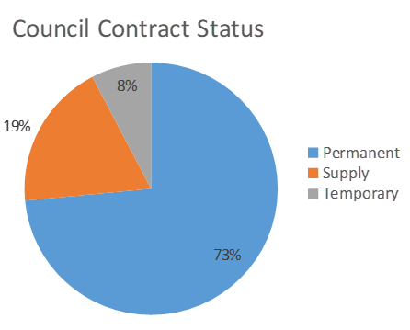
Table 4 Year 2022 Table 5 Year 2022

(Source AC internal data systems) (source NHST internal data systems)

Table 6 Year 2023 Table 7 Year 2023

Vacancy Information
Table 8 shows a snapshot percentage of AHSCP posts that were vacant in 2022 within both the Council and NHS Tayside. Posts become vacant for a variety of reasons but recruiting to them can often prove a lengthy and time-consuming process. Vacancies can therefore have a real impact upon service provision. The staff turnover rate for AHSCP staff employed by Angus Council was 14% for the year 2021/22, with 40% of staff having an average length of service between 15 – 20 years. Updated vacancy information for 2022/23 has not been available.
Table 8
Vacancies | Number | %
Angus Council HSCP Vacant Posts in July 2021 | 57.6wte | c8.5%
NHST AHSCP Vacant Posts in May 2021 | 56.3wte | c 7.2%

Table 9 describes a selection of current NHST staff vacancies, by “job family” in Angus, described using whole time equivalents (wte). It is provided to illustrate current NHST vacancy levels in Angus in comparison with vacancy rates in 2022. It highlights a rise in vacancy rates in 2023 for nursing and midwifery registered staff, medical and dental staff and for pharmacists, with all other groups experiencing a decrease in vacancy rates throughout the last year.

Table 9
 | Job Family | budget (wte) 2022 |  | budget (wte) 2023 | In post  (wte)  2022 |  | In post  (wte)  2023 | Variance (wte)  2022 | Variance  (wte)  2023 | % wte  Vacant  2022 | % wte  Vacant  2023
Medical & Dental | Senior Medical & Dental | 61.5 |  | 61.5 | 51.9 |  | 49.9 | -9.6 | -11.6 | 16% | 18%
Nursing & Midwifery | Nursing + Midwifery-registered | 356.2 | 356.2 |  | 315.6 | 297.3 |  | -40.6 | -58.9 | 11% | 16.5%
Nursing & Midwifery | Nursing + Midwifery-unregistered | 131.2 | 131.2 |  | 110.1 | 110.2 |  | -21.1 | -21 | 16% | 16%
Allied Health Professionals | Occupational Therapists | 32.1 | 32.1 |  | 20.6 | 25.4 |  | -11.5 | -6.7 | 36% | 20.9%
Allied Health Professionals | Physiotherapists | 39.7 | 39.7 |  | 36.4 | 37.4 |  | -3.3 | -2.3 | 8% | 5.8%
Other Therapeutic | Pharmacists | 36.5 | 36.5 |  | 22.4 | * 44.6 |  | -14.1 | -17.6 | 39% | 48.2%
Admin & Clerical | Admin Clerical | 115.3 | 115.3 |  | 110.4 | 116 |  | -4.9 | +0.7 | 4% | +0.6%

[Workforce Directorate, Ninewells]
* Includes pharmacy technicians
Staff Absence
NHS Tayside:
Tables 10 and 11 represent overall absence (%) amongst NHS staff working in the AHSCP. Timescales are indicated in the tables. This indicates an upward trend in overall absence peaking in January 2023 to a higher level than the previous year. This is now declining.
Table 10
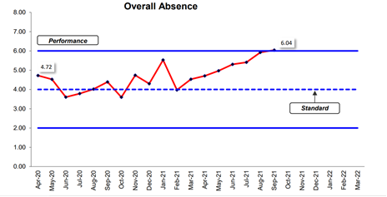
(NHS Tayside Absence Information Report; February 2022)
Table 11

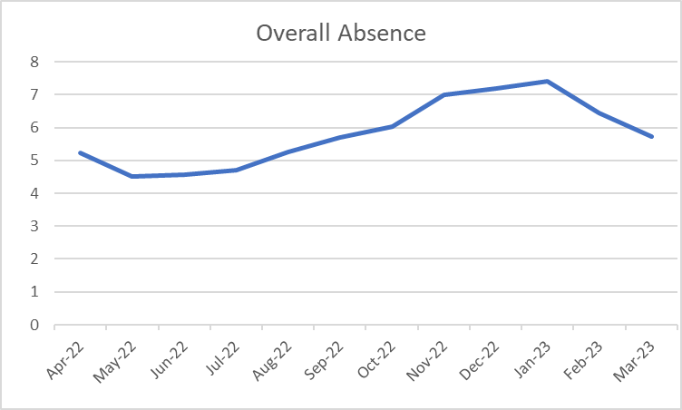
(NHS Tayside Absence Information Report; March 2023)

Tables 12 and 13 represent overall absence (%) amongst NHS job “families” in the Angus Partnership. Nursing, midwifery and support services were the areas with the highest absence rates in 2022. These remain two of the highest overall absence rates illustrated in Table 13 for 2023. However, other therapeutic services have shown an increase in overall absence rates in 2023, to also become one of the highest rate categories with rates rising from 3.90% in 2022 to 5.58% in 2023.

Table 12

(NHS Tayside Absence Information Report; February 2022)
Table 13

(NHS Tayside Absence Information Report; February 2022)

Angus Council
Tables 14 and 15 provide a snapshot of Angus Council absence for staff working in the AHSCP in 2022 and 2023. This indicates a slight increase in absence rates for Mental Health services from 4.47% to 4.71%. It indicates a slight decrease in absence rates for Community Health and Care services from 5.71% to 5.56%. It is interesting to note that the absence rates for Community Health and Care services have decreased significantly since 2021 when the rate was 8.59% – a reduction of almost 50%. This may be partially attributed to the increase in overall staff post numbers and also the increase in the use of permanent posts.
Table 14

(Angus Council HR Data source)
Table 15
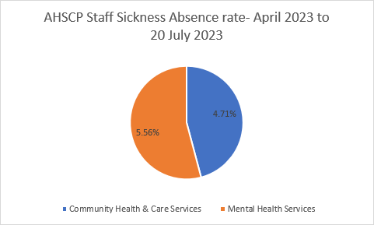
(Angus Council HR Data source)

Table 16 illustrates the main reasons for AHSCP staff sickness absence from April to July 2023. The highest absence reason being psychological.
Table 16
All AHSCP Staff - From April to 20 July 2023

Absence Reasons | Percentage of Absence
Psychological | 30.99
Musculoskeletal | 24.65
Infectious Diseases | 12.98
Respiratory | 6.81
Exploratory | 5.32
Genitourinary & Gynaecological Disorders | 3.56
Cancer | 3.41
Gastroenterological | 3.30
Cardiovascular | 3.29
Ear / Nose / Dental / Throat | 2.94
Neurological | 1.48
Dermatological | 0.87
Endocrine / Glandular Problems | 0.34
Ophthalmological | 0.07

Third and Independent Sector:
There is a national challenge in relation to sourcing workforce data from the third and independent sector. This is an important issue as increasingly services are now being commissioned by third and independent sector organisations. The lack of this information limits our ability to understand our workforce, analyse and forecast workforce demands and take required action to address challenges experienced by various sectors of our workforce. Currently we have limited quantitative information regarding the workforce not employed by NHS Tayside or Angus Council. It is essential to understand the workforce implications, capacity and ability of the third and independent sector and are working with these partners to collate a full picture of the health and social care workforce.
The Scottish Social Services Council (SSSC) have commenced a national dataset for registered workers. However, this does not include absence information. This is an important national issue in understanding our overall workforce challenges, particularly in relation to the increasing demand for care at home provision, much of which is delivered in Angus by the Independent sector.
The known absence level for the independent care at home sector nationally was approximately16% in 2022. No further update of this information has been made available for 2023.
Scottish Care; Workforce Recruitment & Retention Survey Findings (September 2021).
Age
Tables 17 and 18 highlight that 37% of the AHSP’s Nurses were currently aged over fifty-years in 2021 with a slight increase to 35.7% in 2023. During the next few years, as nurses retire, it is likely there will be insufficient nurses available to replace them. The District Nursing - Transformation of Service Programme: A role framework for District Nursing that is being developed across Tayside has a focus on addressing this issue. The largest age group continues to be in the 31-49 year-old category.
Table 17
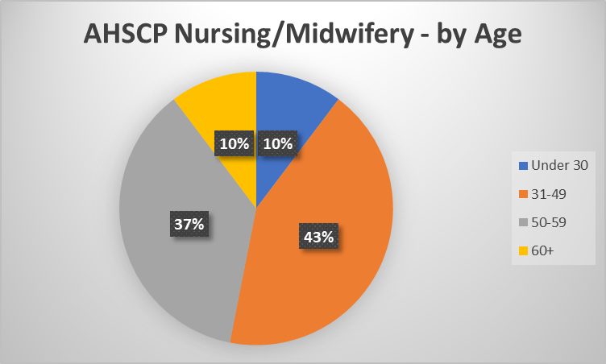
[Source: Information Services, Workforce Directorate, Ninewells Hospital: August 2021 and August 2023]

Table 18
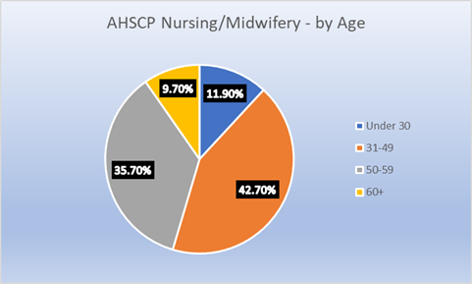

Tables 19 and 20 highlight that 32% of Allied Health Professionals were aged 50 or over in August 2021 which has slightly decreased to 29.10% in 2023, with the largest age group continuing to be the 31-49 year-old category.
Table 19

[Source: Information Services, Workforce Directorate, Ninewells Hospital: August 2021 and August 2023]

Table 20
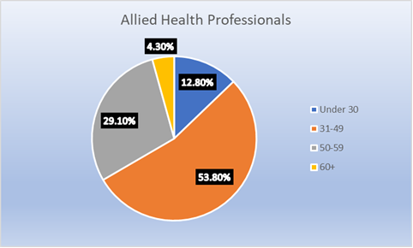

Table 21 contains a summary of some NHS Tayside staff groups working in Angus that have particularly high numbers of staff currently approaching retirement as of 2022. It highlights that around half of the Nurses working in the Forfar / Kirriemuir area for example, are shortly to retire:
Table 21

(AHSCP internal data systems)
Angus Council collects staff age data across slightly different age bands. Table 22 suggests a larger proportion of the Council’s staff are aged under fifty-five years of age than nurses working in the NHS, with 25% of Council staff working within the partnership aged 55 or above. However, it should be noted that another 27% are within the 45 – 55 age bracket. The data provided by both tables presents a challenge for workforce planning and is further exacerbated by the overall reduction in the health and social care workforce and the reducing younger population demographics already mentioned. It further highlights the importance of the workforce activity highlighted in this plan, focussing on the maximisation of resources, using resources to maximum efficiency and taking positive action to attract more people into the workforce of all ages.

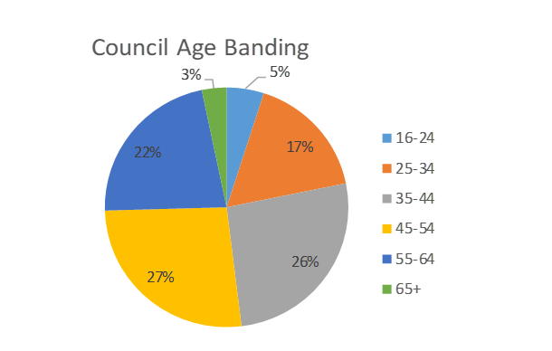
Table 22

[Source: HR, Digital Enablement & Business Support, Angus Council: May 2022]
Table 23 illustrates the anticipated retirements of Council staff working within the AHSCP by age band. This highlights a large percentage of staff in the 60-64 and 55-59 age groups within Community Health and Care services.
Table 24 illustrates that most Council employees working in the AHSCP were over the age of 60 when they retired in 2022.
Table 23

[Source: HR, Digital Enablement & Business Support, Angus Council

Table 24

[Source: HR, Digital Enablement & Business Support, Angus Council: May 2022]
Tables 25 and 26 highlight the proportion of the Council staff working for the AHSCP by age group in May 2022 and in April 2023. Table 25 illustrates that in 2022, the highest proportion of employees by age were the 35-44 and 44-54 age groups. Table 26 highlights that by 2023 this patten remains with the highest proportion of employees being in the 31-49 age group. It should be noted that 19% of current staff are over 60 years with more than half over 50 years (inclusive of the over 60 year age group).
Table 25

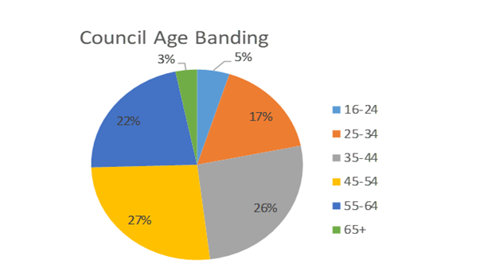
[Source: HR, Digital Enablement & Business Support, Angus Council: May 2022]

Table 26

[Source: HR, Digital Enablement & Business Support, Angus Council: April 2023]
The projected retirement of staff within the next few years will result in loss of experience across the Partnership. This highlights the importance of robust succession planning across the AHSCP to mitigate the risk presented by this loss in experience and numbers of staff.
Gender
Tables 27 and 28 illustrate the proportion of Council staff working within the AHSCP by gender in May 2022 and again in April 2023. A high proportion of staff are female and this trend is increasing from 78% in 2022 to 87% in 2023. Tables 29 and 30 highlight that as of August 2021 a high percentage (83%) of NHS Tayside staff working within the AHSCP are also female and this has remained broadly the same in 2023. The high percentage of female staff across the AHSCP raises implications for the workforce in terms of the impact of parental leave. Although it is recognised that carers leave, child care and flexible working arrangements are available to staff of both genders, the high proportion of female staff across the AHSCP means this may also have an impact on the workforce.
Table 27 Table 28
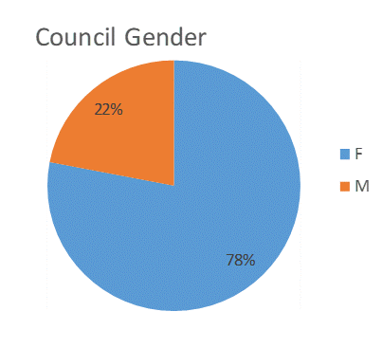
[Source: HR, Digital Enablement & Business Support, Angus Council: May 2022 and April 2023]
Table 29 Table 30
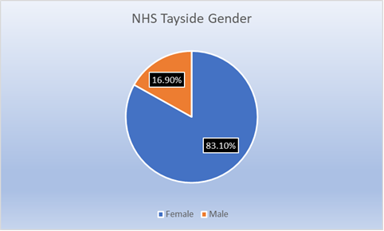
[Source: Information Services, Workforce Directorate, Ninewells Hospital: August 2021 and August 2023]
Workforce Forecasting
Using an assumed average national annual growth (where no mitigating actions have been taken) of around 3.5%* for the healthcare workforce and 4%* for the social care workforce, we can estimate what this means for the overall numbers (head-count) that may be required in Angus over the next 5 years, as illustrated in table 31:
Table 31 Projected numbers of staff that may be required in Angus:
^{Sector} | ²⁰²¹  ^{(Head Count)} | ²⁰²⁶  ^{(Head Count)} | ^{Projected}  ^{Increase.}
^{Angus Council} | ⁷³⁷ | ⁸⁸² | ¹⁴⁵
^{NHS} | ⁹⁵² | ^{1,117} | ¹⁶⁵
^{Care Homes} | ^{1,478`} | ^{1,773} | ²⁹⁵
^{Care at Home} | ¹⁸⁶⁰ | ^{2,230} | ³⁷⁰
^{Totals:} | ⁵⁰²⁷ | ^{6,002} | ⁹⁷⁵
*(Draft National Workforce Strategy for Health and Social Care in Scotland, 2021)
Table 31 suggests that without taking any mitigating actions, by 2026 Angus may require an additional 975 staff in total. Importantly, the highest proportion of those additional staff would be required in the Care at Home sector, as this remains our strategic planning objective to keep more people at home for longer, where it is safe to do so. It is likely that Table 31 would see a greater reduction in care home head count and a greater increase in care at home head count, than is currently illustrated in the table, which is based on national projections.
Given the projected growth in health and care service demand, solely increasing our workforce is not sustainable, or achievable.
The improvement activity detailed in Section 2 demonstrates the work undertaken to make best use of our existing resources through remodelling and redesigning services towards more innovative ways of working and delivering services. It illustrates areas where existing staffing resource is being transferred in response to changing needs and demographics; alongside the introduction of new roles to meet changing demands and/or to combat particular role shortages and includes areas where we have increased staffing resources. Table 31 gives a general illustration of what this requirement may look like if we do not take these mitigating actions. However, this does not consider the additional staff resource we have recently established and those we are in the process of establishing, all of which impact on projections of required posts/roles in the future.
We need to continue to drive forward with these improvements to address the workforce challenges that are being experienced and to further progress the shift in how we manage our workforce, moving from “how many” to “how we work” to achieve a sustainable workforce. We feel our improvement activity is aligned to this perspective.

SECTION 5: THE ACTION PLAN

Priority Planning
Our workforce priorities in the last 12 months have focussed on 5 main priority areas:
- Staff Health and Wellbeing
- Recruitment and Retention
- Workforce Data
- Learning and Development
- Safer Staffing

Five multi-agency workforce sub groups have been driving forward this work in relation to our four workforce priority areas in addition to the comprehensive range of improvement activity being progressed across services within the AHSCP.

These priority areas encapsulate the workforce challenges highlighted within this report in relation to, for example, succession planning, the ageing workforce, leadership development, attracting a younger workforce, having robust workforce data to inform our workforce forecasting and assumptions, changing demographics and labour supply, financial constraints, staff skills requirements, staff retention and the wellbeing of our workforce. These workforce priorities therefore remain current and relevant for our next 12 month cycle of workforce planning activity to continue to address our workforce challenges and risks.

Action planning
Our annual Action Plan Update 2023 details the priority actions that will be taken over the next 3 years to mitigate the risks and challenges identified in this workforce plan. It provides an update on the progress of these actions and highlights new actions being progressed in response to emerging priorities over the last 12 months.
The actions are focussed on addressing the workforce challenges highlighted in the plan, are intricately linked to the strategic financial plan and include a variety of governance arrangements for the identified improvement activity.
Resources have been secured for many of the actions currently in progress. Financial planning remains key to addressing the workforce challenges facing the AHSCP and robust processes are in place to ensure our actions are achievable within the current financial constraints.
SECTION 6: IMPLEMENTING, MONITORING AND REVIEWING

Implementation
The AHSCP Senior Leadership Team remain responsible for implementing the AHSCP Workforce Plan. Monitoring and review of the plan and action plan is the responsibility of the AHSCP Workforce Steering group.
Measuring Progress
The Plan will be monitored through the AHSCP Workforce Steering group in order to measure progress. The group will report on progress to the AHSCP Executive Management Team. Workforce risk is reported regularly to the AHSCP Clinical and Care Governance Group. Progress reports are submitted to NHS Tayside, Angus Council and the Angus Staff Partnership Forum. The Chief Officer provides an annual update to the Integration Joint Board.
Reviewing the Plan
The action plan is co-ordinated by the AHSCP Workforce Steering Group. The purpose of the Workforce Steering Group is to provide a strong, effective, integrated and collaborative partnership forum that will improve workforce planning and ensure that collectively the group possess the required expertise, skills, knowledge and resources to analyse, forecast, and plan workforce supply and demand.
The action plan will continue to be reviewed on an annual basis for the duration of the 3 year Workforce Plan period to ensure it remains focussed on priority challenges amidst a changing landscape. The Angus Health and Social Care Partnership has and will continue to place workforce and workforce development at the core of how the partnership delivers on positive outcomes for individuals and strategic priorities. AHSCP will therefore work with partners to deliver integrated workforce planning.

Glossary of Terms and Abbreviations
AC | Angus Council
AHP | Allied Health Professional
AHSCP | Angus Health and Social Care Partnership
AIDARS | Angus Integrated Drug and Alcohol Recovery Service
AMP | Approved Medical Practitioner
ANP | Advanced Nurse Practitioner
ASP | Adult Support and Protection
AWI | Adults with Incapacity
CRT | Community Response Team
DN | District Nurse
ECS | Enhanced Community Support
ERT | Enablement and Response Team
EQIA | Equality Impact Assessment
FTE | Full-time Equivalent
GP | General Practitioner
IJB | Integration Joint Board
LTC’s | Long Term Conditions
m | Million
MAT | Medically Assisted Treatment
MHO | Mental Health Officer
MIIU | Minor Injury and Illness Unit
MSK | Musculoskeletal
NE | North East
NHS | National Health Service
NHST | National Health Service Tayside
NQSW | Newly Qualified Social Worker
NRS | National Records of Scotland
NW | North West
ONS | Office for National Statistics
OOHS | Out of Hours Service
OT | Occupational Therapist
QSW | Qualifying Social Worker
SE | South East
SSSC | Scottish Social Services Council
SW | Social Worker
VAA | Voluntary Action Angus
WTE | Whole Time Equivalent

